**Digital Nurture 4.0 Java FSE**

**Week 6 ReactJS - HOL**

**Additional Mandatory Exercise (HandsOn 6)**

**Exercise 06:** Cognizant Academy teams want to maintain a list of trainers along with their expertise in a SPA using React as the technology. You are assigned the task of creating this React app.

The following trainers’ data application will deal.

1. T-ID
2. Name
3. Phone
4. Email
5. Stream
6. Skills

Create a new React app using *create-react-app* tool with the as “TrainersApp”

**Answer:**

**App.js:**

import { BrowserRouter, Routes, Route, Link } from 'react-router-dom';

import Home from './Home';

import TrainersList from './TrainersList';

import TrainerDetail from './TrainerDetail';

import { trainersMock } from './TrainersMock';

function App() {

  return (

    <BrowserRouter>

      <div>

        <h1>My Academy Trainers App</h1>

        <nav>

          <Link to="/">Home</Link> | <Link to="/trainers">Show Trainers</Link>

        </nav>

        <hr />

        <Routes>

          <Route path="/" element={<Home />} />

          <Route path="/trainers" element={<TrainersList trainers={trainersMock} />} />

          <Route path="/trainers/:id" element={<TrainerDetail />} />

        </Routes>

      </div>

    </BrowserRouter>

  );

}

export default App;

**Trainer.js:**

class Trainer {

  constructor(trainerId, name, email, phone, technology, skills) {

    this.trainerId = trainerId;

    this.name = name;

    this.email = email;

    this.phone = phone;

    this.technology = technology;

    this.skills = skills;

  }

}

export default Trainer;

**TrainerMock.js:**

import Trainer from './Trainer';

export const trainersMock = [

  new Trainer(201, "Aarav Mehta", "aarav.mehta@academy.com", "9871112233", "Node.js", ["Express", "MongoDB", "REST API"]),

  new Trainer(202, "Priya Desai", "priya.desai@academy.com", "9123344556", "React", ["Hooks", "Routing", "Styled Components"]),

  new Trainer(203, "Anirudh Iyer", "anirudh.iyer@academy.com", "9988776655", "Python", ["Flask", "Data Analysis", "Pandas"]),

  new Trainer(204, "Neha Kapoor", "neha.kapoor@academy.com", "9011223344", "Java", ["Spring MVC", "JPA", "Microservices"]),

  new Trainer(205, "Karthik Nair", "karthik.nair@academy.com", "9345678822", "Angular", ["Components", "RxJS", "NgRx"]),

  new Trainer(206, "Sanya Reddy", "sanya.reddy@academy.com", "9887766554", "C#", ["ASP.NET", "Entity Framework", "LINQ"]),

  new Trainer(207, "Rahul Verma", "rahul.verma@academy.com", "9654321098", "DevOps", ["Docker", "Kubernetes", "CI/CD"]),

];

**TrainerDetails.js:**

import { useParams } from 'react-router-dom';

import { trainersMock } from './TrainersMock';

function TrainerDetail() {

  const { id } = useParams();

  const trainer = trainersMock.find(t => t.trainerId === parseInt(id));

return trainer ? (

    <div>

      <h2>{trainer.name}'s Details</h2>

      <p><strong>Email:</strong> {trainer.email}</p>

      <p><strong>Phone:</strong> {trainer.phone}</p>

      <p><strong>Stream:</strong> {trainer.technology}</p>

      <p><strong>Skills:</strong> {trainer.skills.join(", ")}</p>

    </div>

  ) : (

    <div>Trainer not found </div>

  );

}

export default TrainerDetail;

**Home.js:**

function Home() {

  return (

    <div>

      <h2>Welcome to My Academy trainers page</h2>

    </div>

  );

}

export default Home;

**TrainersList.js:**

import { Link } from 'react-router-dom';

function TrainersList({ trainers }) {

  return (

    <div>

      <h2>Trainers List</h2>

      <ul>

        {trainers.map(t => (

          <li key={t.trainerId}>

            <Link to={`/trainers/${t.trainerId}`}>{t.name}</Link>

          </li>

        ))}

      </ul>

    </div>

  );

}

export default TrainersList;

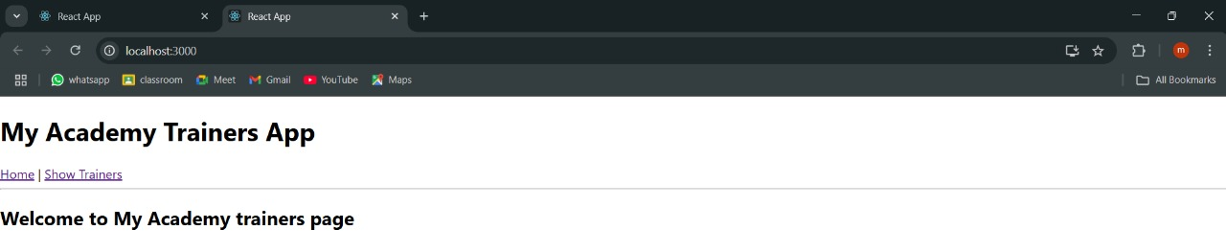**Output:**

